**Password Security System**

**Group Members:**

1. Saad Ahmad (20P-0051)
2. Farhan Abbasi (20P-0044)

This is a Password Security System. Which compares the password entered by the user with the set password. The concept of comparator is used in this system.

**Items used:**

1. **Exclusive – NOR Gate**

|  |  |  |
| --- | --- | --- |
| A | B | X |
| 0 | 0 | 1 |
| 0 | 1 | 0 |
| 1 | 0 | 0 |
| 1 | 1 | 1 |

1. **AND Gate**

|  |  |  |
| --- | --- | --- |
| A | B | X |
| 0 | 0 | 0 |
| 0 | 1 | 0 |
| 1 | 0 | 0 |
| 1 | 1 | 1 |

1. **NAND Gate**

|  |  |  |
| --- | --- | --- |
| A | B | X |
| 0 | 0 | 1 |
| 0 | 1 | 1 |
| 1 | 0 | 1 |
| 1 | 1 | 0 |

1. **NOT Gate**

|  |  |
| --- | --- |
| A | X |
| 0 | 1 |
| 1 | 0 |

1. **JK Flip Flop:**

|  |  |  |  |
| --- | --- | --- | --- |
| J | K | Q | Q’ |
| 0 | 0 | NC | NC |
| 0 | 1 | 0 | 1 |
| 1 | 0 | 1 | 0 |
| 1 | 1 | Q’ | Q |

**Analysis:**

This system consists of 21 toggle switches i.e., 16 of them are connected to the flop flips individually i.e each flip receiving 4 inputs, 2 as J and K inputs whereas other 2 as preset and clear. Flip flops store the password which is the set password or default password. The Flip Flops also receive a push button as a clock to it which acts synchronously, which enables us to change the values of Q and Q’ which is the value of set password also. The Flip flops also have preset and clear to set and reset the values stored in the flip flop. 1 toggle switch is to enable the system at the end of the circuit, 4 switches are for entering the password by the user and other.

The values of Qs from the flip flops go to the XNOR gates as an input.

As the Ex-NOR is used for comparing the bits so there are 4 Ex-NOR gates to check the password whether it is same or not. Each

Ex-NOR takes 2 bits i.e., 1 bit from the user and the other bit from the set password (Q value of Flip Flop) and compares them. These Ex-NOR gates are directly connected to the AND gate having 4 inputs and with NAND gate which also have 4 inputs. The output of AND gate and NAND gate become the input of another two individual AND gates connected to the enable switch, which take 2 inputs. There are two bulbs which are directly connected individually to each output of the AND Gates.

**Circuit of Password Security System:**

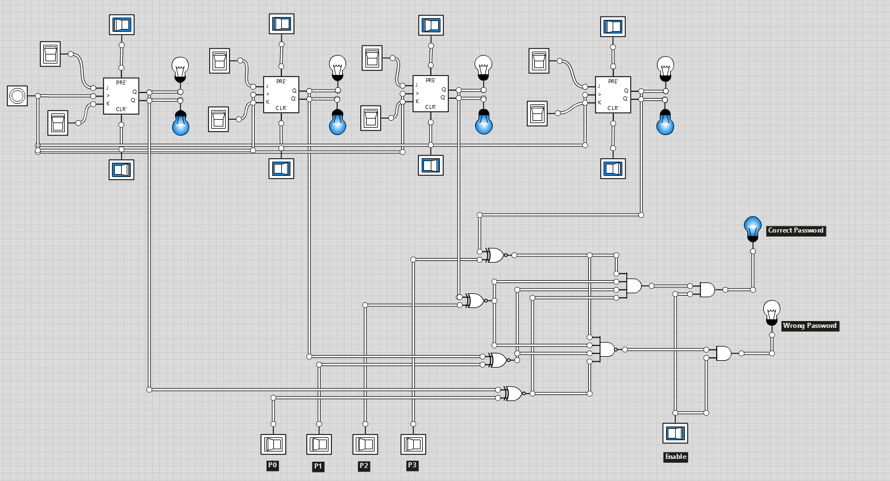

**Truth Table:**

**W.P** = Wrong Password

**C.P** = Correct Password

|  |  |  |  |  |  |  |
| --- | --- | --- | --- | --- | --- | --- |
| Enable | D3 P3 | D2 P2 | D1 P1 | D0 P0 | W.P | C.P |
| 1 | D3 > P3 | X | X | X | 1 | 0 |
| 1 | D3 < P3 | X | X | X | 1 | 0 |
| 1 | D3 = P3 | D2 > B2 | X | X | 1 | 0 |
| 1 | D3 = P3 | D2 < B2 | X | X | 1 | 0 |
| 1 | D3 = P3 | D2 = B2 | D1 > P1 | X | 1 | 0 |
| 1 | D3 = P3 | D2 = B2 | D1 < P1 | X | 1 | 0 |
| 1 | D3 = P3 | D2 = B2 | D1=P1 | A0 > B0 | 1 | 0 |
| 1 | D3 = P3 | D2 = B2 | D1=P1 | A0 < B0 | 1 | 0 |
| 1 | D3 = P3 | D2 =B2 | D1=P1 | A0 =B0 | 0 | 1 |

**Boolean Expression:**

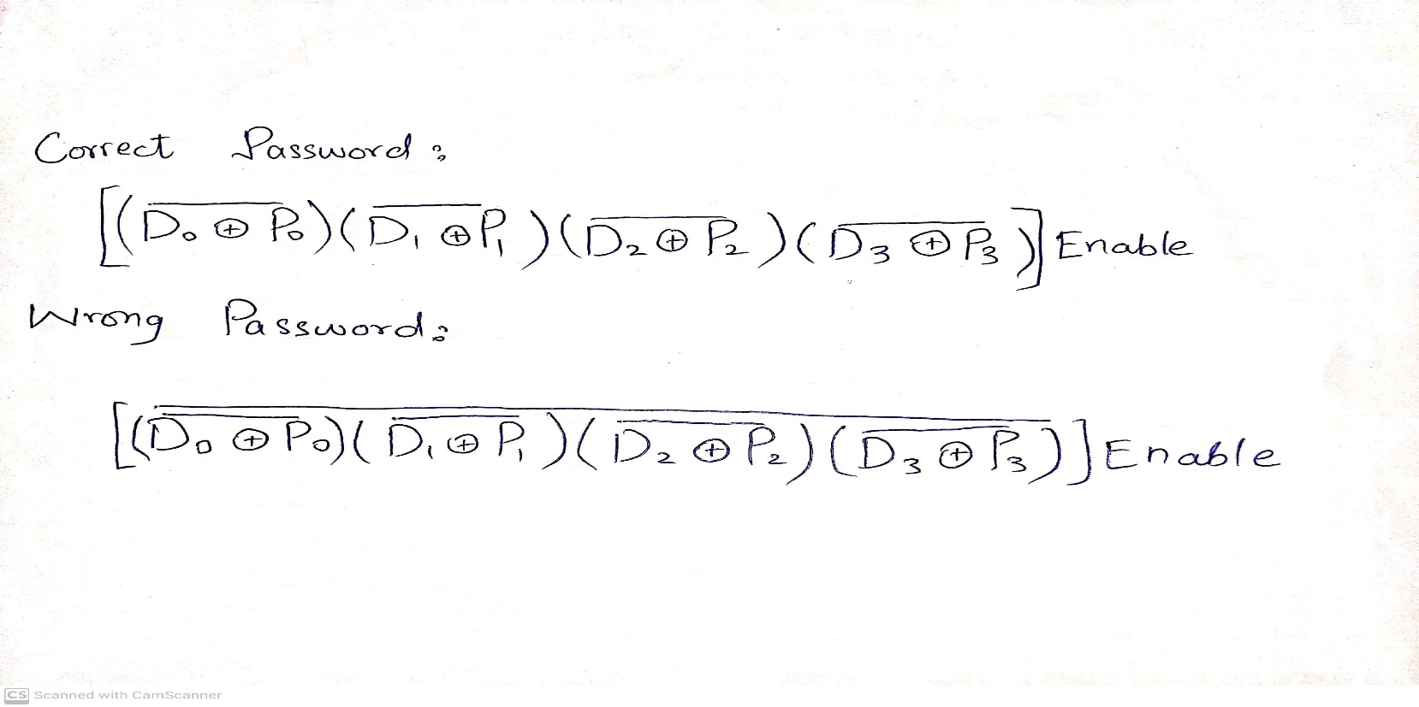

**Optimization Technique:**

We used Exclusive NOR gate instead of combination of Exclusive OR and an Inverter. We used single AND gate instead of 3 AND gates for the outputs from XNOR gates. Use JK Flip Flops for storing the passwords.

**Simulator link:**

<https://logic.ly/>